Memorandum

Case No.: 2207006

|  |  |
| --- | --- |
| *To:* | Dr. Horst Hohberger, Chair of Faculty Committee on Discipline |
| *From:* | Zhou Wanqing, Chair of Honor Council (On behalf of Honor Council) |
| *Subject:* | *Decision Regarding an Alleged Violation of the Honor Code* |
| *CC:* | Horst Hohberger (Course Instructor), Shuyu Wu, Yuqi Mai, Hanwen Zhang, Yuyang Chen, Hanlin Gao |
| *Date:* | July 30, 2022 |

|  |  |
| --- | --- |
| Instructor | Horst Hohberger |
| Report Date | April 27, 2022 |
| Course Code | ECE4010J (Probabilistic Methods in Engineering) |
| Course Work | Team Project |
| Hearing Date | July 31, 2022 |

|  |  |
| --- | --- |
| Student Name | Shuyu Wu |
| Student ID | 520370910097 |
| Decision | Innocent |
| Violation Count | 0 |
|  |  |
| Student Name | Yuqi Mai |
| Student ID | 520021910367 |
| Decision | Guilty |
| Violation Count | 1 |
|  |  |
| Student Name | Hanwen Zhang |
| Student ID | 519370910177 |
| Decision | Innocent |
| Violation Count | 0 |
|  |  |
| Student Name | Yuyang Chen |
| Student ID | 519370910168 |
| Decision | Innocent |
| Violation Count | 0 |
|  |  |
| Student Name | Hanlin Gao |
| Student ID | 520021910213 |
| Decision | Innocent |
| Violation Count | 0 |

**According to the instructor Horst Hohberger:**

These students are in project group 8. Section 3 of "Spring 2022 - Group 8 - Term project report.pdf" appears to be very similar to Section 5 of "Spring 2019 - Group 17 - Term project report.pdf".

**Investigation findings on July 30 2022**

From these two reports, it’s clear that several parts within the two reports are similar.

Identical sentences, identical label of figures, identical format, etc.

|  |  |  |  |
| --- | --- | --- | --- |
| # | Group 8 (2022) | # | Group 17 (2019) |
| 5,6 |  | 14 |  |
| 6 |  | 15 |  |
| 6,7 |  | 16,17 |  |
| 9 |  | 17 |  |

We estimate that in Section 3 of Group 8’s report, there is about 10% of plagiarism.

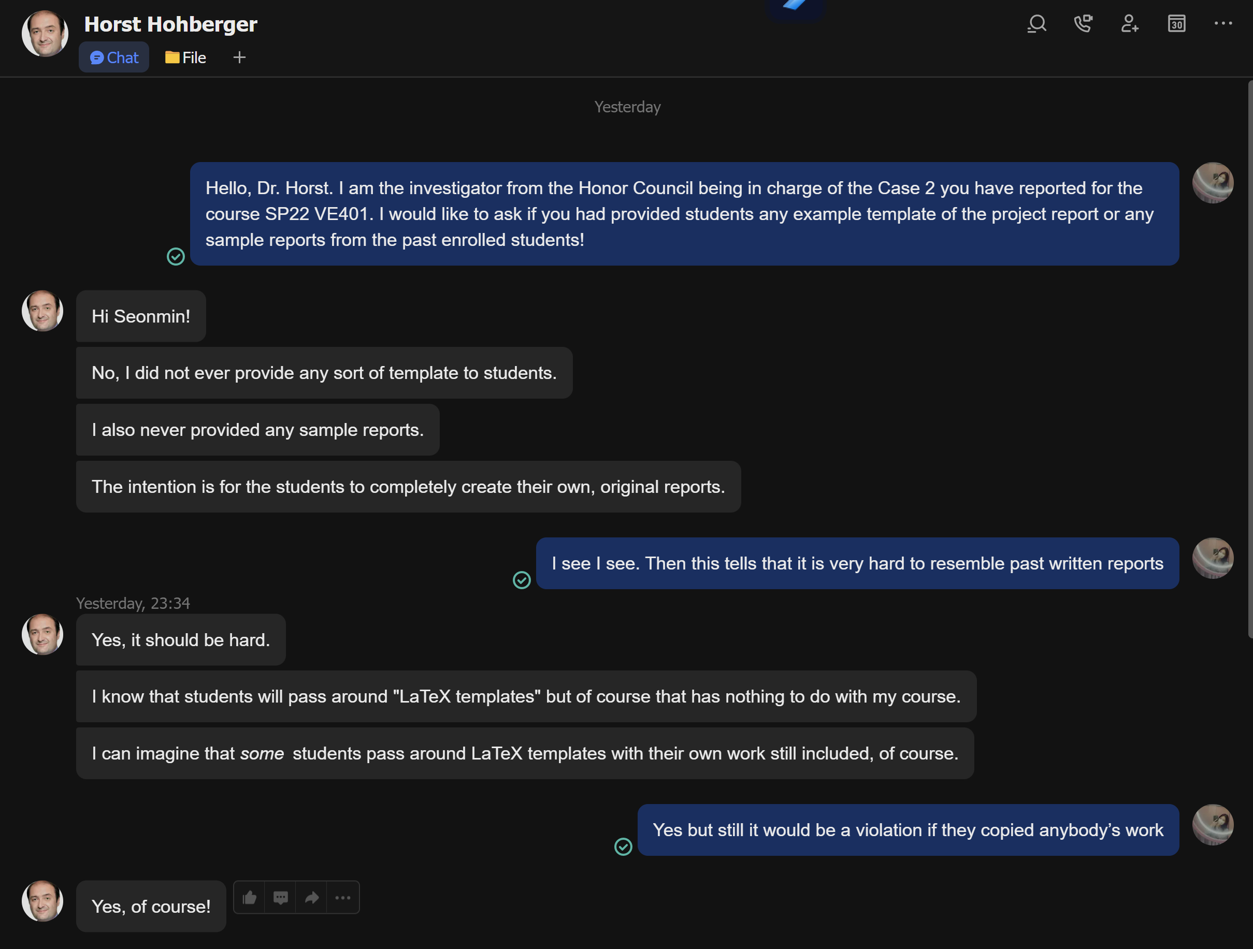

Figure 1 Feishu chat history between the investigator and Dr. Horst (July 29)

Since he never provides any sample work or template to students, it should be hard to resemble past works.

**Account of Shuyu Wu on July 30 2022:**

Shuyu Wu insists that the sections that were reported for plagiarism were strictly done by Yuqi Mai. He further states that he himself as well as the other members excluding Yuqi Mai should not be responsible for this misconduct for two big reasons. The first reason is that members of the group had no idea that Yuqi Mai copied the work from outside resources since it is very difficult to notice when the student does not reveal anything about it. He states that the parts of the project were strictly distributed among the teammates and Yuqi Mai was the one who took the role in those plagiarized sections. Shuyu Wu has shared the Wechat history of dividing up the work. The second reason is that he had tried his best on correcting the errors from Yuqi Mai’s work caused from direct copying of the previous report. However, the remaining errors that made Dr.Horst to report his team was out of his control and responsibility. He has shared the materials that proves his effort on modifying errors that Yuqi Mai made. Last but not least, Dr. Horst agreed that the teammates should be judge individually, since not all of them may have been involved in this misconduct.

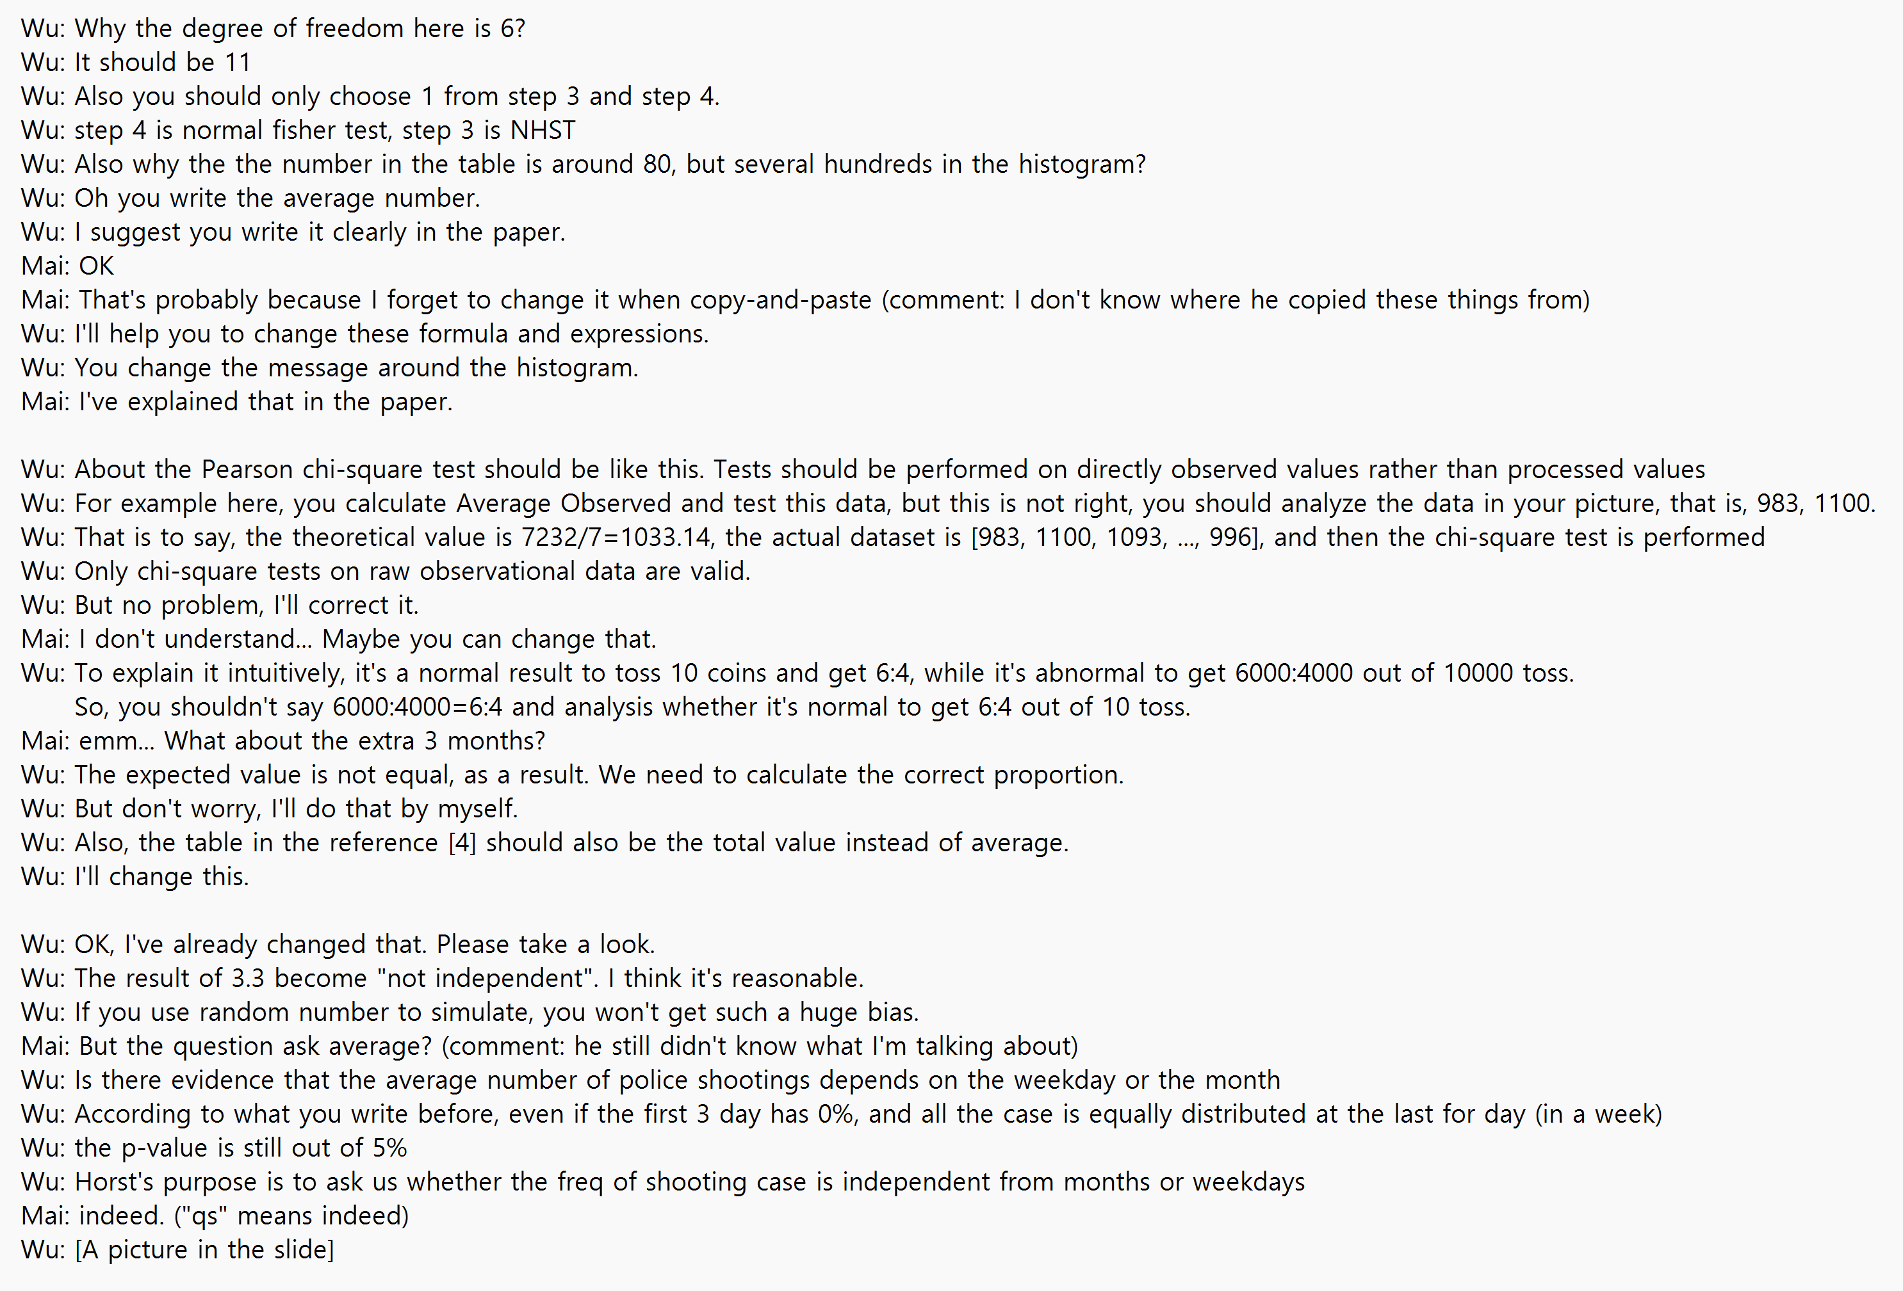

Figure 2 Wechat history between Shuyu Wu and Yuqi Mai

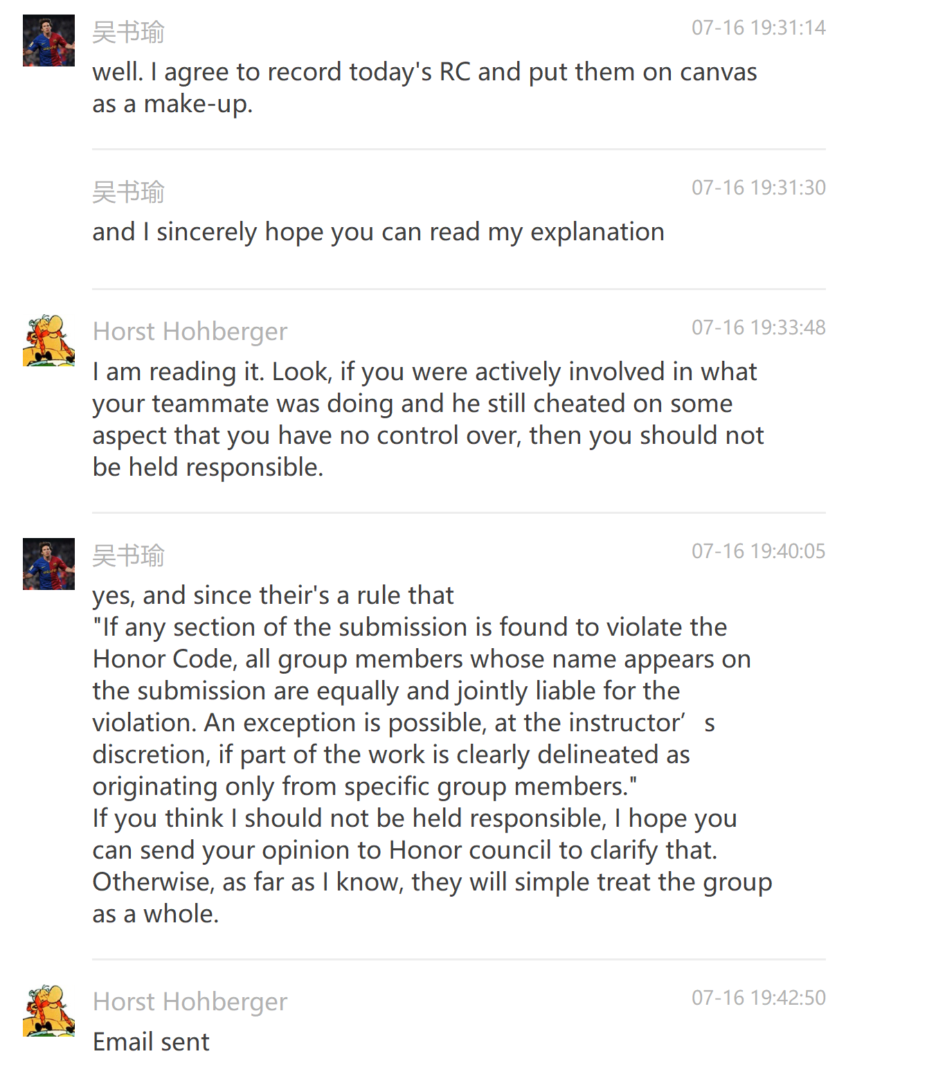

Figure 3 Wechat history between Shuyu Wu and Dr. Horst

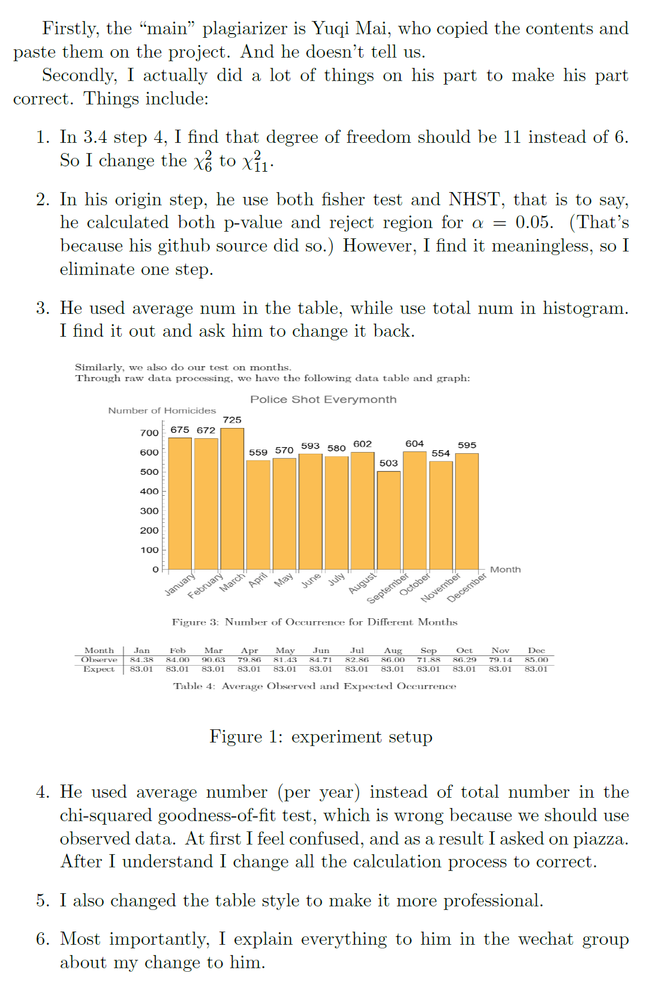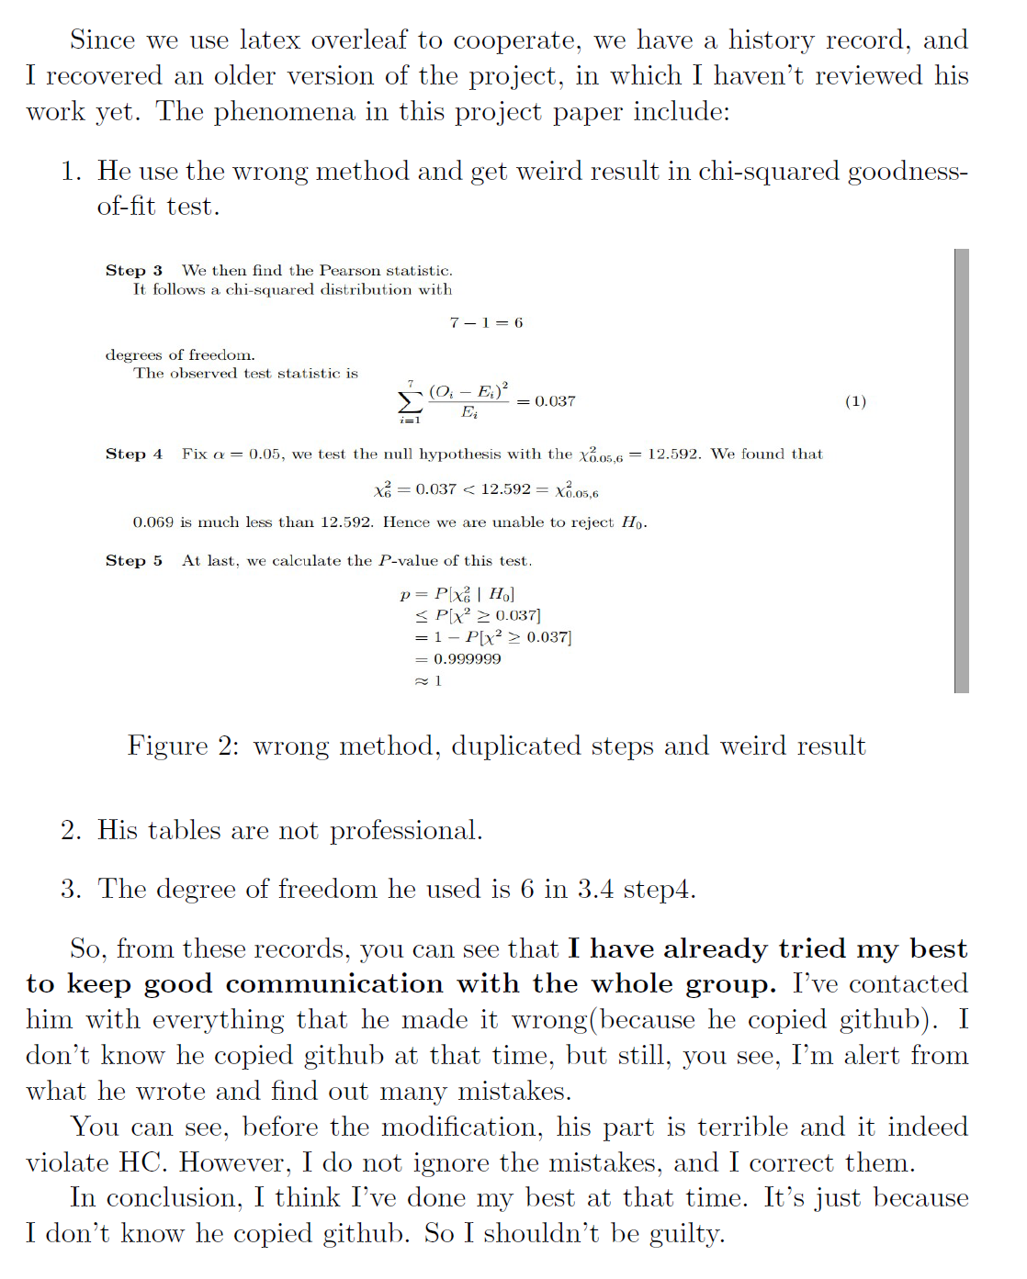

Figure 4 List of things Shuyu Wu tries to correct errors made from Yuqi Mai

**Account of Hanwen Zhang on July 30 2022:**

Hanwen Zhang states that he should not be involved in this misconduct as he took a completely different role on this project from the problematic part of the report. Yuqi Mai was in charge of Problem 4 while Hanwen Zhang was in charge of Problem 5. He also provided Wechat history of distributing the workload among the members. He concludes that this is why he truly had no idea about the plagiarism.

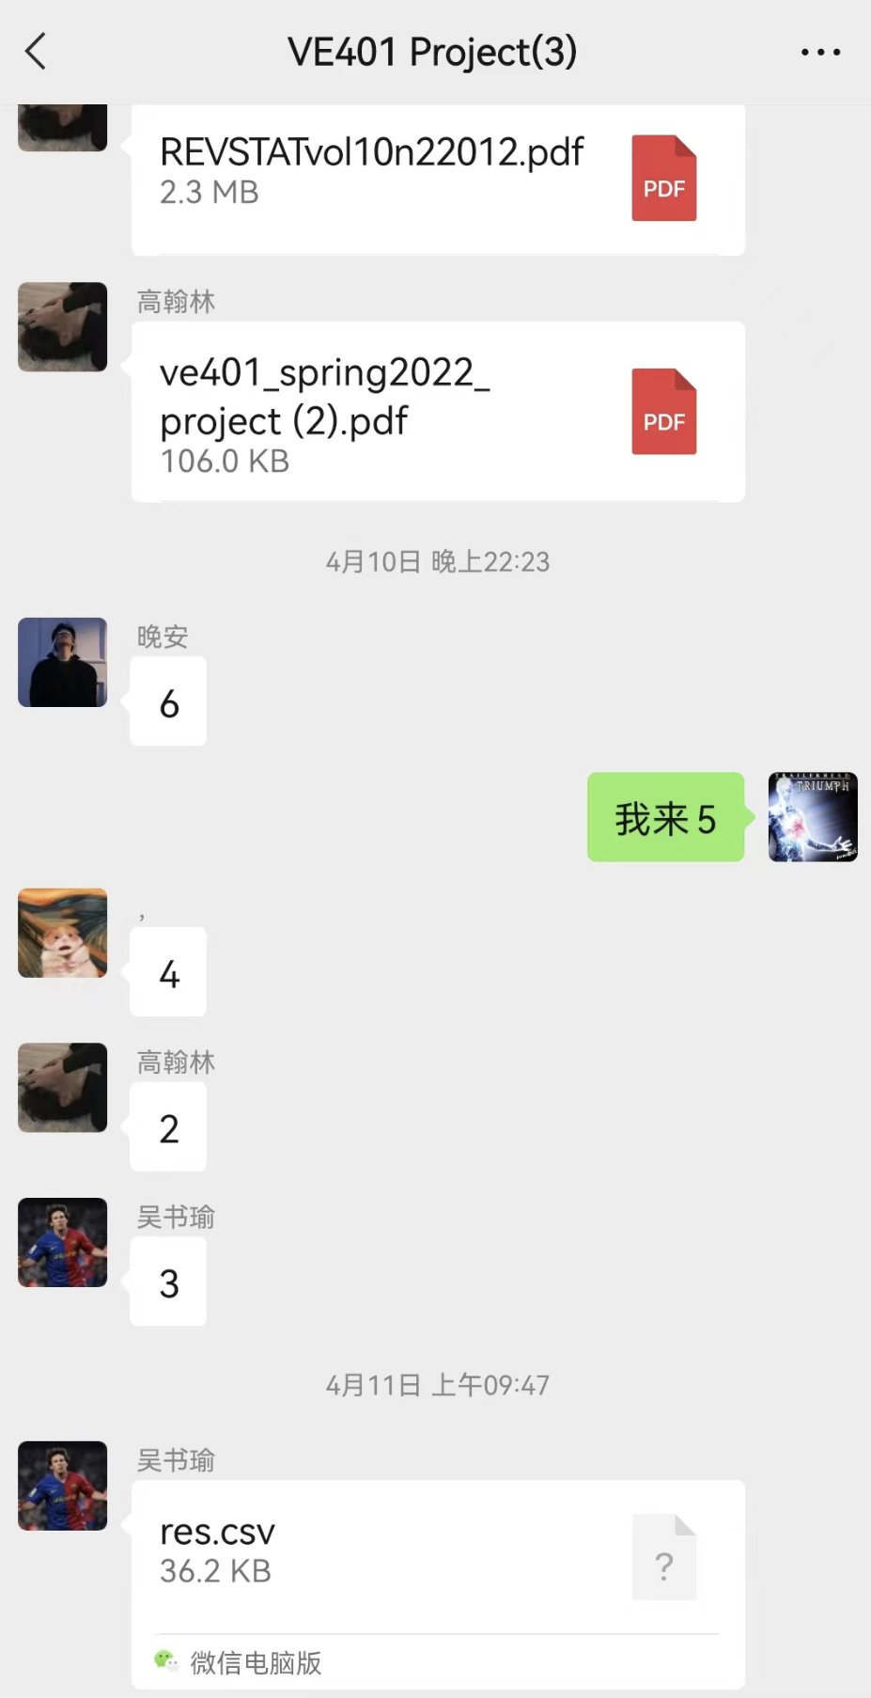

Figure 5 Wechat history of the team dividing up the work

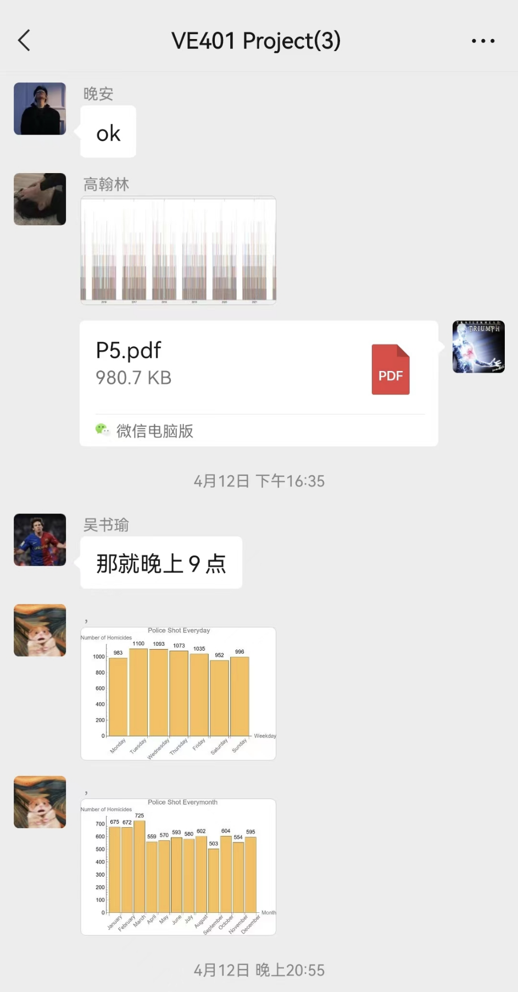

Figure 6 Evidence of Hanwen Zhang submitting his part done solely by himself

**Account of Yuqi Mai on July 30 2022:**

Yuqi Mai admits that he had copied the report from previously enrolled students, and he states that he agrees the other members of the team should not be guilty of this violation. However, he adds on that not all pieces of evidence are his plagiarism. He states that he did copy the introduction part of the previous report but had done data processing and value-calculations by himself. Moreover, he explains that the error found in the degree of freedom and graphs were due to his chosen methods of calculations which were incorrect rather than him copying from the previous report (i.e. chose the same processing methods for finding the number of police shooting every day (section 3.3) and every month (section 3.4); chose the average value sum instead of direct value sum). He then concludes that he admits his misconduct and is willing to face the consequence of the Honor Code violation.

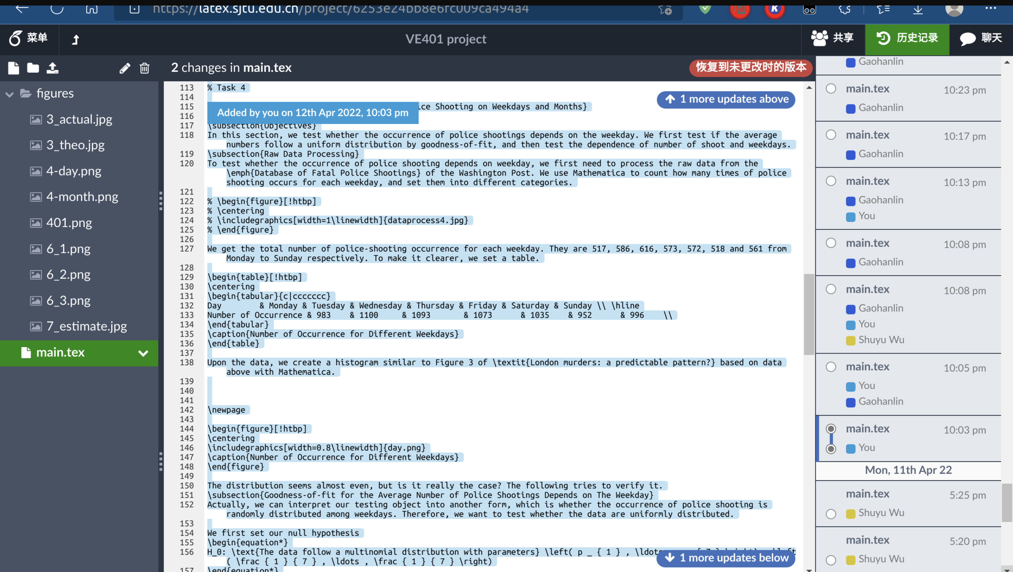

Figure 7 Overleaf edit history

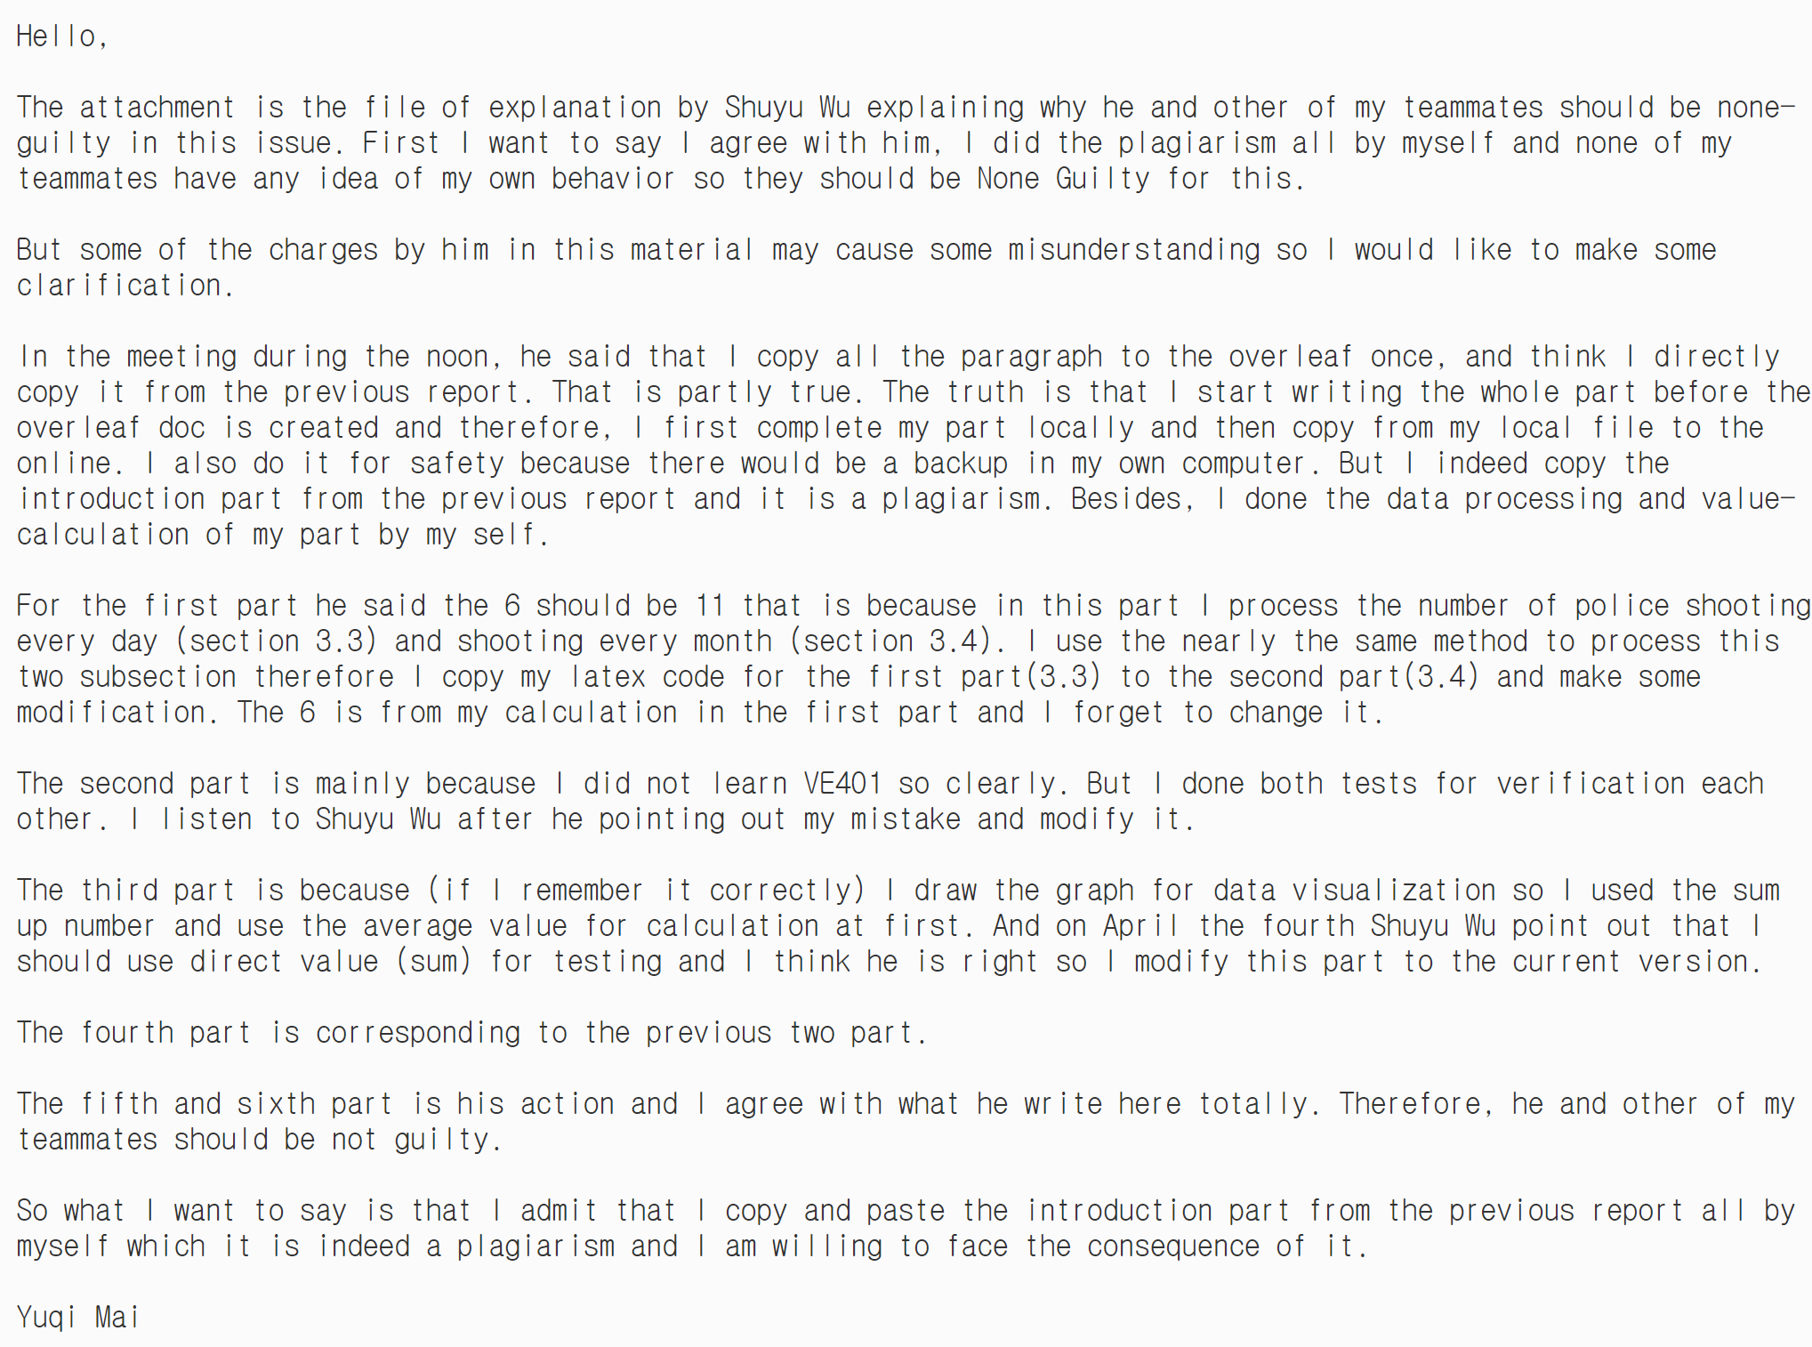

Figure 8 Email sent to the investigator from Yuqi Mai, explaining based on Shuyu Wu's account

**In the hearing on July 31, 2022,**

Based on the fact that the team members of Group 8 excluding Yuqi Mai was not involved in direct copying of the past report, the Honor Council decided to judge the members individually. Since Yuqi Mai certainly plagiarized previously enrolled students’ work, the Honor Council decides that Yuqi Mai is guilty by vote.

The students or the course instructor may lodge an appeal with the Faculty Commission on Discipline (FCD) within 7 days of receipt of the decision. After this period, the finding of the Honor Council becomes final and irreversible. Sanctions for students found guilty will be imposed by the FCD. The FCD may be contacted at [jifcd@sjtu.edu.cn](mailto:jifcd@sjtu.edu.cn) for appeals and other questions.

If you have any question or need additional information regarding this case, please feel free to contact us.